

QF634 - Applied Quantitative Research Methods

**Forecasting conditional correlations between stock indices for efficient hedging and portfolio construction in 2022 market downturn**

**Prepared By:**

Chang Ting Yu

Cassidy Gan

Nam Sangkyu

Bryan Seah

1. **Introduction**

Correlation – the statistic describing the co-movement of 2 variables – is commonly used in the practice of finance. It features prominently in Modern Portfolio Theory which was introduced by Harry Markowitz in 1952 and has since become one of the landmark models in finance. Modern Portfolio Theory seeks to optimize the weights in a portfolio of assets on the basis of their expected returns, volatility and correlations. Implicit in the model is the assumption that correlations between assets are static, such that historical correlations are representative of future correlations. This model has been widely applied by finance professionals in allocating assets for investors. In particular, these finance professionals focus on building portfolios with assets that have inverse correlations, the most well known of which is the 60/40 equity/bond portfolio. Theoretically, this will reduce the volatility of portfolio returns and has served investors well for decades, with studies showing a historical return of 8.8% from 1 Jan 1926 to 31 December 2021.

However, thus far in 2022, the 60/40 portfolio is on track to experiencing its worst performance in a century - as touted by numerous finance and business publications. This can be attributed to the fact that the correlation between equities and bonds were strongly positive – with both assets experiencing double digit drawdowns in 2022. In particular, the 5-year rolling correlation between the Russell 1000 index (broadly representing the US stock market) and the Aggregate index (broadly representing all US dollar denominated investment grade bonds) flipped from negative to positive at a scale not seen since the 2000.

This increase in correlations during times of financial turmoil is a well-studied phenomenon known as “contagion”. Practically, this means that markets tend to move closely together when they become agitated. Examples include the Asian financial crisis in 1997, the Russian default in 1998, and the Great Financial Crisis in 2008. These events were precipitated in local markets (Thai baht devaluation, Russian bond defaults, US subprime mortgage defaults), but had reverberations across neighboring and distant markets the world over. In addition to having spillover effects between geographic regions, contagion has also been shown to apply across various asset classes. These studies serve to highlight to investors and financial professionals the failures and unreliability of diversification and portfolio hedging on the basis of modern portfolio theory and fixed historical correlations at critical junctures. Assets across geographies and asset classes will perform similarly in times of financial stress and thereby lessening any diversification benefits, and in most cases, exacerbating the impacts of market downturns.

Given the dangers of relying on fixed correlations, there have been many studies focusing on correlation and co-movements between financial instruments and geographies, which has led to the development of various advanced econometric approaches, such as DCC-GARCH (Dynamic Conditional Correlation - Generalised Autoregressive Conditional Heteroskedasticity). Models like DCC-GARCH are used to model and forecast time-varying conditional correlations between asset classes, which can then be used to construct more robust portfolio allocations and hedges.

In a related line of research, models have been developed to apply conditional covariances and variances to estimate dynamic hedge ratios and optimal portfolio weights which take into account the time-varying nature of the relationships between asset classes. These models take advantage of the comovements between assets to create more cost efficient long-short portfolios - where a long position in one stock market can be hedged by shorting the futures in a correlated market.

To further the existing research on this topic, this paper explores the dynamic linkages between major international stock markets. Using daily stock indices closing levels, we aim to model their dynamic correlation and spillover effects using DCC-GARCH. On top of that, we conduct a 1 year rolling forecast of correlations at daily intervals for the period of December 2021 to December 2022. Based on the forecasted correlation, we construct a hedging ratio for SPX versus other indices on a pair-wise basis. This provides some insights for how equity portfolio diversification would have helped with returns over the past year.

Interestingly, we are forecasting into the most recent 1 year period, which has received limited attention by papers using multivariate GARCH models. In this period, we see central banks hopping on a hiking cycle one after another to contain inflation, despite the world still living under the shadows of potential economic deterioration from Ukraine-Russia triggered energy shocks, Covid-induced supply chain disruption, and Covid restrictions dampening demand. That saw VIX touching the 30 area twice in 2022, with the 1990-2022 average at 19.67. This paper provides insight to how volatility has spread, and how portfolio managers can hedge using ratios generated by DCC-GARCH this year, given past information.

1. **Literature review**

The simplest method of estimating the dependencies between markets is linear correlation (specifically Pearson’s correlation coefficient). One of the key reasons for adopting this measure has been how straightforward it is to calculate (Embrechts, McNeil and Straumann. 1998). However, correlation is only a symmetric, linear dependence metric, and cannot fully capture the time-varying characteristics of dependencies between markets (Aslanidis, Osborn and Sensier, 2008). To this end, Generalised AutoRegressive Conditional Heteroskedasticity (GARCH) models provide a better understanding.

Many models have been developed since 1988 to understand the time-varying nature of dependencies between markets. The DCC-GARCH was proposed by Engle in 2002, and it addressed a number of limitations in the models up to that point. This was soon widely accepted and applied to model dynamic correlations in various settings. The specifications of the DCC-GARCH will be explained in detail below.

In Xiao & Dhesi (2010), the authors applied both the Baba-Engle-Kraft-Kroner model and DCC-GARCH to test the time-varying correlations across 4 stock markets: CAC, DAX, FTSE and S&P 500, spanning from 2004 to 2009. The research found that the UK and US were the major volatility exporters in Europe and worldwide respectively. Further, they found that the time-varying conditional correlations were mean-reverting.

In Jebran *et al* (2017), the authors applied an extended exponential GARCH model to examine the asymmetric volatility spillover effects from 2001 to 2013 between 5 emerging markets: China, Pakistan, Hong Kong, Sri Lanka, India. The authors found that bidirectional volatility spillovers exist between various pairs of markets, and that the pre-crisis and post-crisis periods had different pairs - indicating that the relationships were not stable across different market regimes.

In Zhong & Liu (2021) the authors explored the correlations and volatility spillover effects between China and ASEAN stock markets. The authors applied 4 different multivariate GARCH models to analyse the relationships between China and 5 South-East Asian stock markets between 1994 and 2019. Comparing the results from the 4 methods, the authors found the DCC-GARCH to fit the underlying data best. Further, they also found significant increases in the correlations during times of financial crisis - in 1997, 2008 and 2015.

We note that the various research efforts in the area of stock market volatility spillover and dynamic correlations between American, European and Asia Pacific stock markets do not consider the latest global market events that have occurred in the last 3 years, 2020 to 2022. This means that the impacts of the various differing COVID lockdown policies on domestic markets as well as general market turmoil in 2022, have not yet been analysed using the framework of dynamic conditional correlations. This paper seeks to address this gap, as well as construct theoretical hedged portfolios and test their performance.

1. **Methodology**

This study is primarily focused on applying the DCC-GARCH model (Engle, 2002) to investigate the time-varying correlations between the various stock indices. The results derived from this model will also be used to calculate efficient hedging ratios and optimal portfolio weights. The DCC-GARCH model specifications as well as the the hedging ratio and portfolio weights estimators are as follows:

- the vector of return time series (given the information set at time can be described as a combination of the vector of conditional means and a vector of residuals:

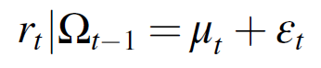

The vector of unconditional means can be modeled using an AR*(p)* process, with the number of lags determined by the Akaike Information Criterion.

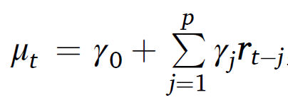

The vector of residuals is assumed to be normally distributed with a mean of 0 and covariance matrix .

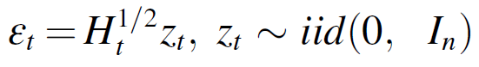

In the DCC model, the covariance matrix is time-varying, and is given by the product of and .



is the diagonal matrix of standard deviations from univariate GARCH models fit to each of the *n* assets. Under the DCC model, follows a univariate GARCH (1,1) process:

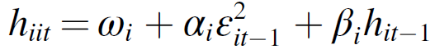

is the dynamic conditional correlation matrix, and is calculated using , which is the conditional variance-covariance matrix.





is the unconditional variance matrix of (introduced above). and denote the short-term and long-term persistence of shocks to the DCC model respectively. We note that in other common notation, they are represented by and .

1. **Data**

We use 7 indices across regions. US S&P 500, Nikkei 225, Korea Stock Exchange KOSPI Index, Hang Seng Index, Taiwan Capitalization Weighted Stock Index, FTSE100, and S&P/ASX 200 index. The data is daily, spans from June 1992 to 6 December 2022, with the last 250 data points used as out of sample period. Data is sourced from bloomberg.

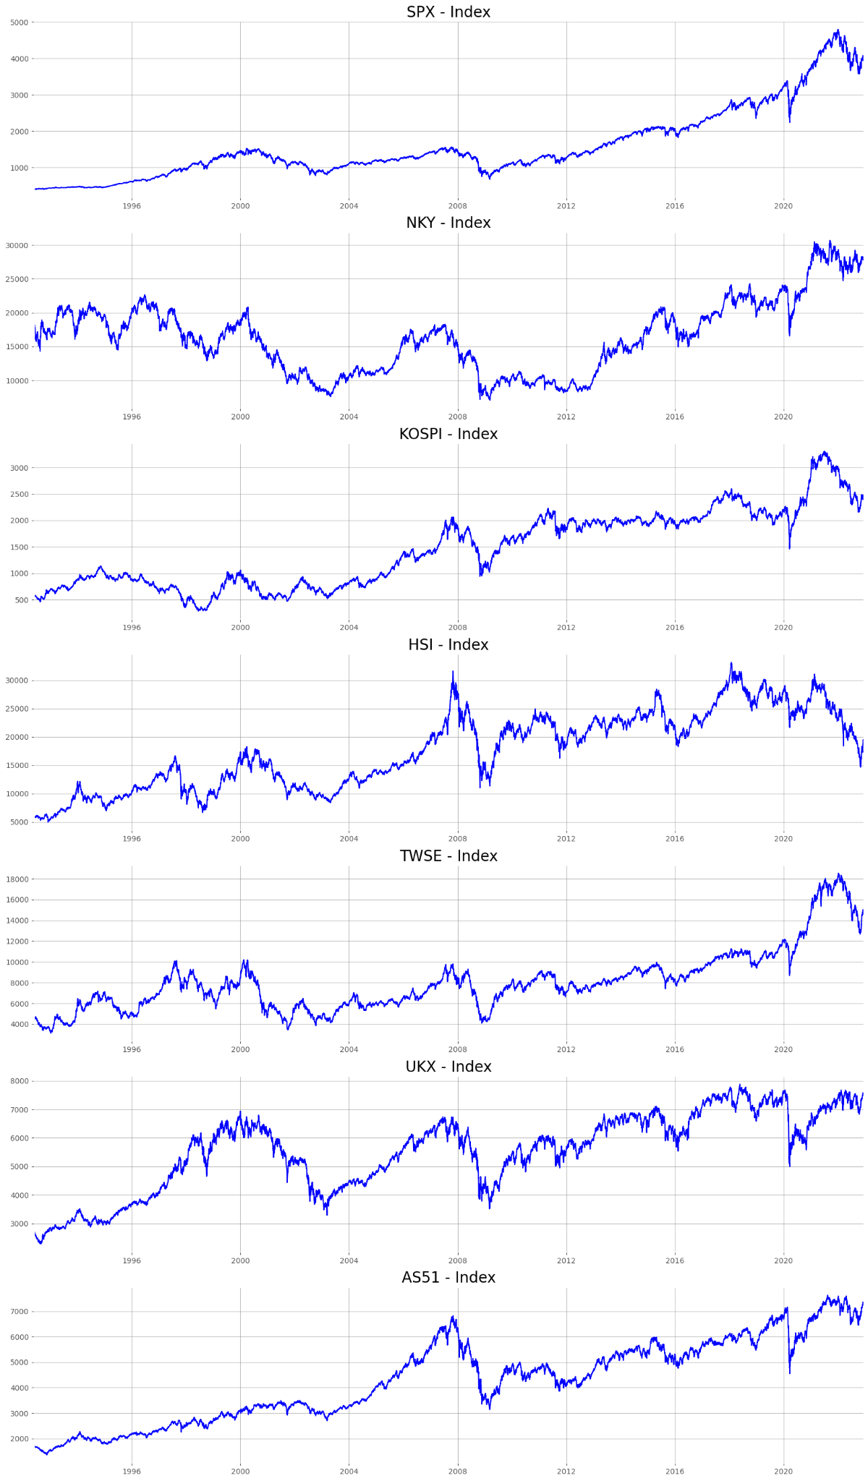

While it is the futures on indices that are tradable contracts, the link between index level and futures is usually sufficiently close. We use historical index data for model building, so as to remove nuances about futures contracts such as liquidity and trading hours from our analysis. For evaluating of the performance of portfolio weights, actively traded futures returns are used as that is where hedging practicality is considered. In any case, the weights and constituents of major indices are often public, so they can be replicated with underlying stocks where futures are unavailable.

Data is transformed into log returns before modeling.

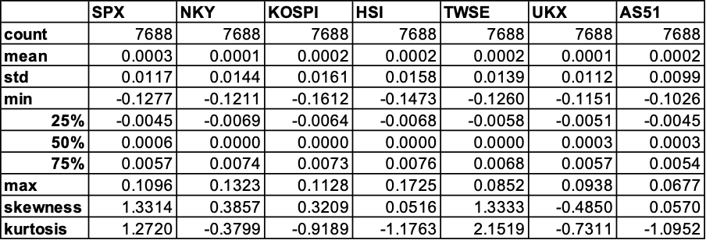

Table1. Descriptive Statistics of Indices.

Over the data period, the highest unconditional correlation is between SPX and FTSE100 at 52.44%, the lowest unconditional correlation is between SPX and the Taiwan Index, at 10.58%.

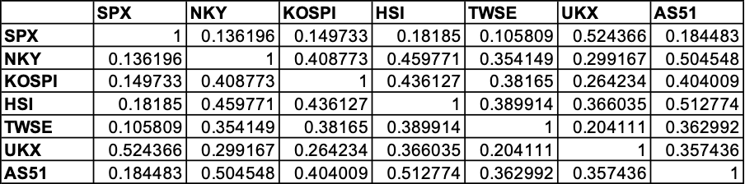

Table2. Correlation of Index Returns.

**Unit Root Test and Conditional Heteroskedasticity Test**

As financial series are often non-stationary by nature, taking the log return should address this issue. Here, KPSS and ADF are used to test for stationarity of the log return series. Kwiatkowski–Phillips–Schmidt–Shin (KPSS) has the null hypothesis that a time series is trend stationary. The large P-values reported shows that the log returns of the indices have no trend component. The null hypothesis of the augmented Dickey–Fuller test (ADF) is that time series has a unit root, which is rejected across the index returns. Therefore our returns are proven to be stationary at a reasonable level.

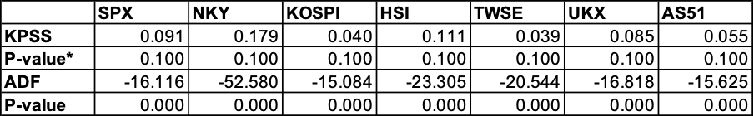

**\****where P-value indicates 0.1, actual P-value larger than 0.1.*

Table3. Test Results for KPSS and ADF

ARMA models are fitted and the errors are used to test for conditional heteroskedasticity. Squared errors are tested with Ljung-box with 10 lags. The null hypothesis for Ljung-Box is that there is no autocorrelation for the chosen lag, which is rejected across the competent series. The ARCH-Lagrange Multiplier (ARCH-LM) test is conducted to assess the significance of ARCH effects using squared residuals, with the null being that there is no ARCH effect. Below shows the ARMA models that were fitted and the result of their ARCH-LM test shows that ARCH/GARCH-type models should be deployed.

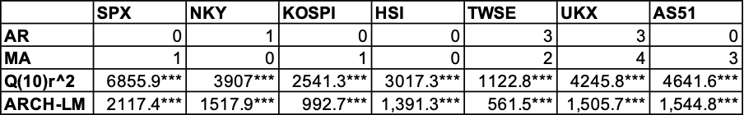

*\*\*\* denotes the rejection of the null hypothesis at the 1% significance level.*

Table4. Test Results for ARCH-LM

1. **Empirical Results**

**5.1 Dynamic Conditional Correlation Estimates**

DCC-GARCH(1,1) is fitted across the timeframe, with the last 250 data points as out of sample. Univariate GARCH(1,1) is first fitted to component series, whose standard deviations are then used in DCC-GARCH(1,1). Table 5 reports the results using the full dataset from June 1992. From reading Panel 1 of Table 5, alpha and beta are all positive, and mostly statistically significant. We find evidence for a positive volatility shock feeding from previous to next period (alpha) and also positive longer term impact (beta). Beta is larger than alpha, indicating that past volatility is more important than shocks for forecasting future market volatility. Sum of alpha and beta are close to 1, showing overall persistence of shocks and volatility from the past. From reading Panel 2 of Table 5, there is positive and statistically significant alpha and beta for dynamic conditional correlation as well (dcca1, dcca2), indicating significant shock and long term effect on dynamic conditional correlation. This suggests the presence of time-varying correlation. Again, with beta larger than alpha, long term persistence plays a larger role in future prediction.

For robustness check, data is sliced into smaller time frame. Table 6 reports the results of the most recent 10 years of data. Table 7 reports the results of the most recent 3 years of data. They show similar results, with positive and mostly significant alpha and beta for GARCH(1,1), and for DCC alpha and beta. Interestingly, with shorter time frames, alpha increases and beta decreases, showing some evidence that short run analysis may see short term shocks playing an more important role in forecasting.

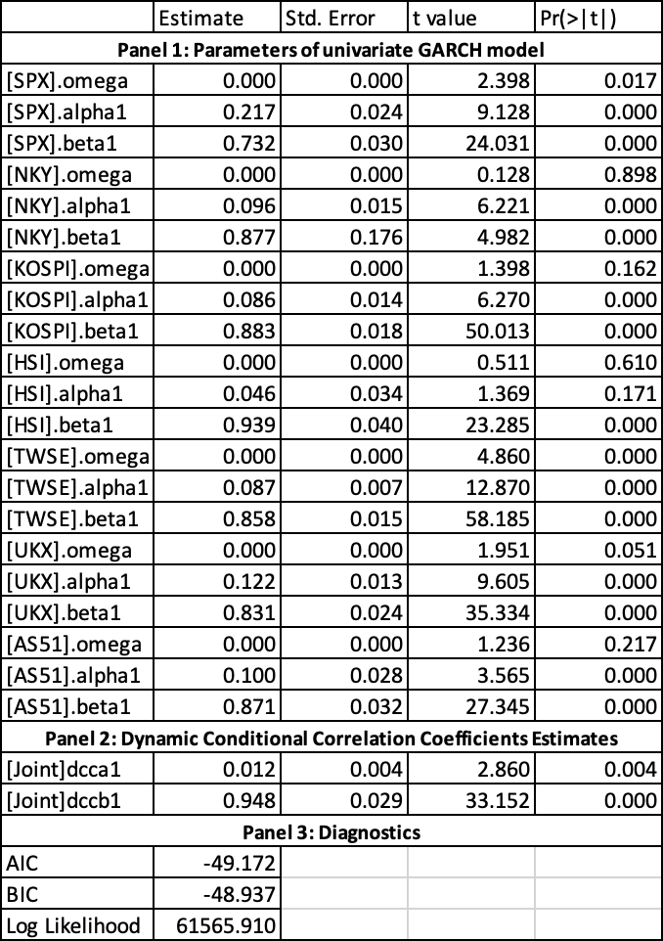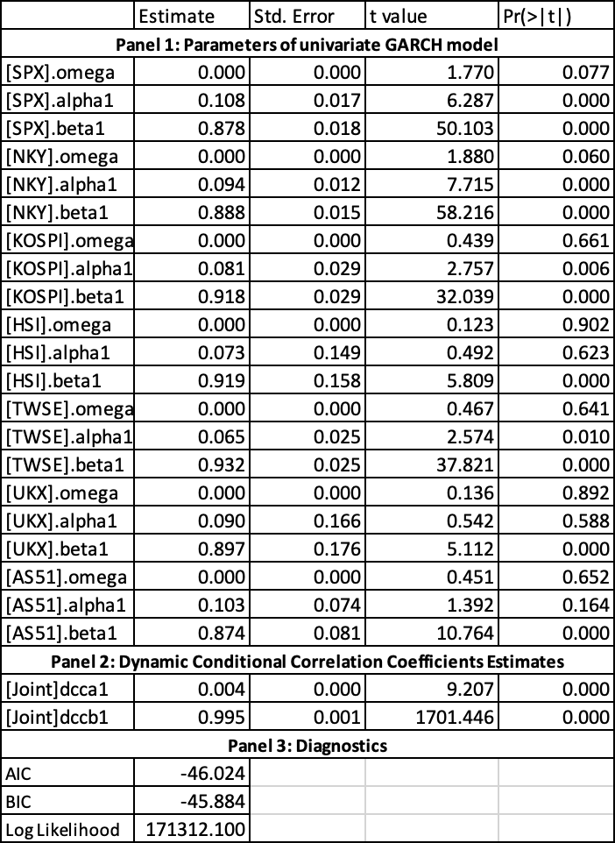



Following model fitting, the squared standardised errors of the DCC-GARCH(1,1) goes through a Ljung-Box test with 10 lags. The results are reported in Table 8. The large P-values show that the model has a decent fit that captures sufficient information on the variance. Also the ARCH-LM test is deployed, showing similar results that there is no further ARCH effect to be captured after the DCC-GARCH(1,1) model is fitted.

Moving on, results in Table 5, which uses the full dataset, is used to conduct a rolling forecast for the upcoming 250 data points, i.e. for the period of Dec 2021 to Dec 2022. The forecasts will then be used to construct hedging ratios in the later section.

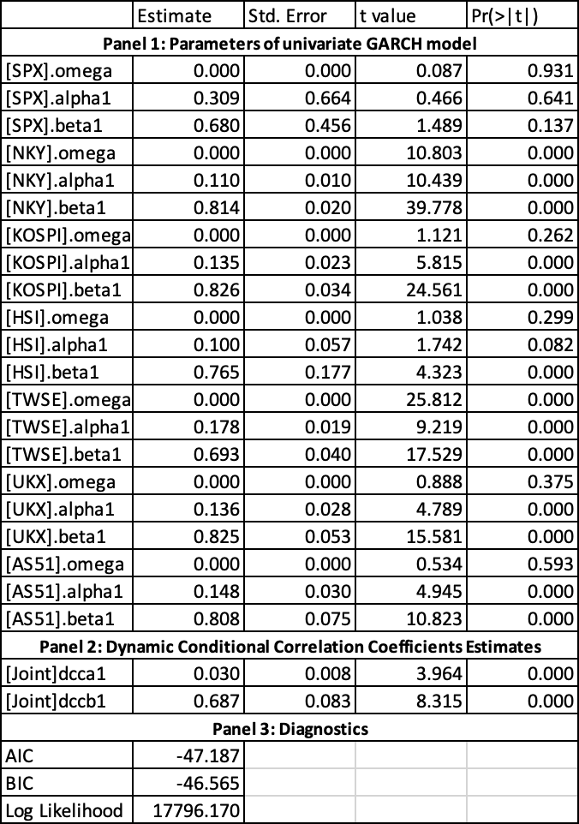



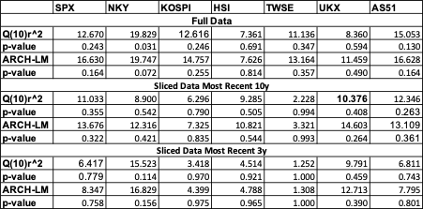



**5.2 Hedge Ratio**

Construction of the hedge ratio can be done using estimated conditional volatility from the DCC model (Kroner & Sultan, 1993). The hedge ratio between asset *i* and asset *j* is:



This indicates that a long position in a first asset *i* can be hedged with a short position in a second asset *j,* where *h* is the conditional covariance.

For most of the hedge ratio, it is visible that the graph *(Figure A)* is moderately variable across the period (one-year range) and has shown a tendency to revert to its mean level. Moreover, the hedge ratio has shown the most volatility across most pairs in between the 2022-05 to 2022-07 period where the largest values of the hedge ratios for most pairs were achieved as well.

The average values of the hedge ratio between SPX and NKY, KOSPI, HSI and TWSE (East Asia) are 0.3223, 0.2872, 0.1482, and 0.2719 respectively *(table 9)*. The average values of the hedge ratio between SPX and UKX is 0.6102, and between SPX and AS51 is 0.4469. These results show that having to hedge using east asia indices is comparably cheaper than the other two regions. Besides, it is important establishing that $1 long position in S&P 500 Index (SPX) can be hedged for 32.23 cents by short position in Nikkei 225 Index (NKY), or else follow by 28.72 cents short position in KOSPI Index (KOSPI), 14.82 cents short position in HANG SENG Index (HSI), 27.19 cents short position in Taiwan Stock Exchange Index (TWSE), 61.02 cents short position in FTSE 100 Index (UKX), or 44.69 cents short position in ASX 200 Index (AS51).

The cheapest hedge is long SPX and short HSI while the most expensive hedge is long SPX and short FTSE. Also, it was noticed that there were no maximum values in excess of unity (hedge ratio > 1) among all 6 SPX pairs.

**5.3 Portfolio Weights**

Construction of the optimal portfolio weights can be done using estimated conditional volatility from MGARCH models (Kroner & Ng, 1993). The portfolio weights between asset *i* and asset *j* is:

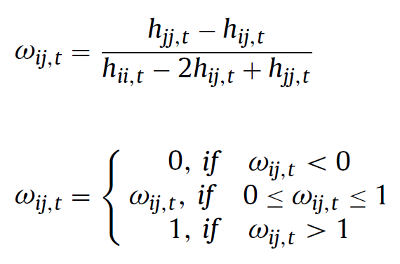

This indicates that the weight of the first asset is Wij and second asset is 1 - Wij between two assets, *i* and *j*, where *h* is the conditional covariance. The average weight for the SPX/NKY portfolio is 0.5796, indicating that for a $1 portfolio 57.96 cents should be invested in SPX and 42.04 cents should be invested in NKY *(Table 10)*. Subsequently, should construct 57.43 cents / 42.57 cents for SPX/KOSPI portfolio, 88.72 cents / 11.28 cents for SPX/HSI portfolio, 58.41 cents / 41.59 cents for SPX/TWSE portfolio, 36.40 cents / 63.60 cents for SPX/ UKX portfolio, and 37.92 cents / 62.08 cents for SPX/AS51 portfolio.

**5.4 Portfolio Return**

Backtesting was done based on 2 strategies which are “Mean Weighted Portfolio” and “Monthly Rebalancing Weighted Portfolio”. There were assumptions made where no trading fee and slippage is considered; however, we specifically backtested on only tradable futures data.

For the first strategy, “Mean Weighted Portfolio”, the average portfolio weight was chosen to compute its return for the trading period of “2021-12-10” to “2022-12-06”. Trade was only executed once on the first day of the trading period.

In general, all hedged portfolios have shown a better result compared to long-only SPX_F (futures, -16.046%) *(Table 11)*. Despite being the cheapest hedge, SPX_F/HSI_F has shown a return of -12.347% which was still better than long only SPX_F return, yet, worst among other portfolios. However, SPX_F/KOSPI_F which was the 3rd cheapest hedge has shown +0.6017% of return where the gap against long only SPX_F is 16.6177%. Other portfolios have achieved a return of -8.2504% for SPX_F/NKY_F, -1.5848% for SPX_F/TWSE_F, -7.7714% for SPX_F/UKX_F, and -5.4248% for SPX_F/AS51_F.

For the second strategy, “Monthly Rebalancing Weighted Portfolio”, portfolio weight was revised every first good business day of the month and executed to compute its return for the trading period of “2022-01-03” to “2022-12-06”. Its first trade was executed around 3 weeks later than the first strategy in order to fulfill the condition of the first day of month trading principle here. Trade was executed 12 times in total on every first day of the trading period.

In general, all hedge portfolios have shown even better results compared to long-only SPX_F (futures, -17.0957%) *(Table 12)*. SPX_F/KOSPI_F which was the 3rd cheapest hedge has shown +5.6861% of return where the gap against long only SPX_F is 22.7818%. The cheapest hedge, SPX_F/HSI_F, has shown -8.7304% of return. The worst performance was shown by the SPX_F/NKY_F portfolio with a return of -15.7938%. Subsequently, other portfolios have achieved a return of +2.5607% for SPX_F/TWSE_F, -6.3938% for SPX_F/UKX_F, and -2.9337% for SPX_F/AS51_F.

In both strategies, hedged portfolios have outperformed long-only SPX_F for

their given trading time period. Despite 3 weeks difference in trading period, the second strategy has clearly shown a better result in return apart from SPX_F/NKY_F portfolio. Also, notice that not every east asia’s performance was better than the other 2 regions' performance unlike the hedge ratio order.

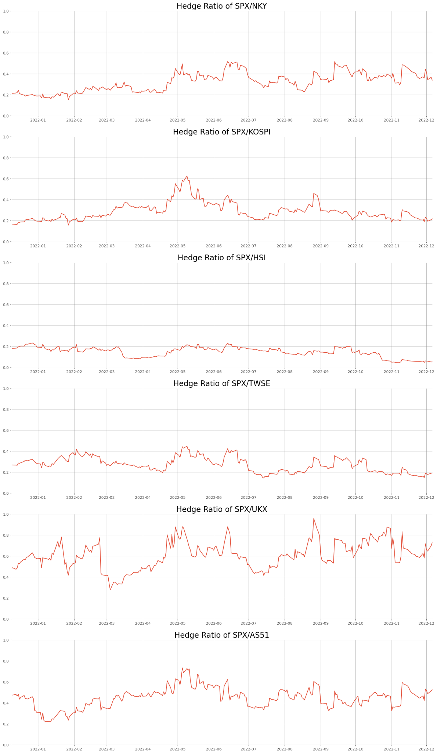

Figure A. Dynamic hedge ratios of each SPX pair

**Table 9**

Hedge ratio (long/short) summary statistics.

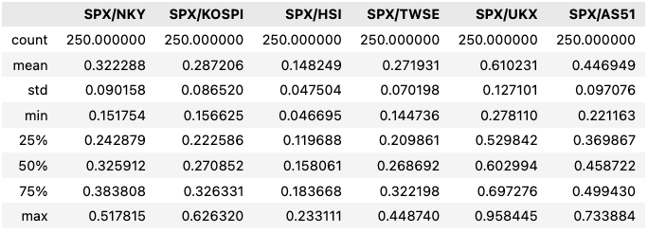

**Table 10**

Portfolio weights summary statistics.

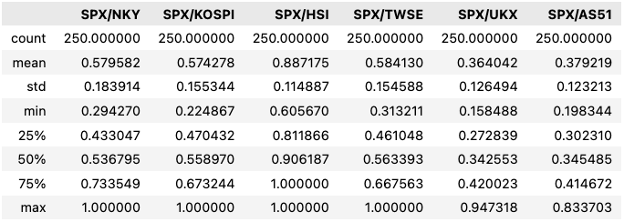

**Table 11**

Mean weighted portfolio return (Period 2021-12-10 to 2022-12-06)



**Table 12**

Monthly rebalancing weighted portfolio return (Period 2022-01-01 to 2022-12-06)



**References**

Aslanidis, Osborn, & Sensier. (2008, February 2). *Co-movements between US and UK stock prices: the roles of macroeconomic information and time-varying conditional correlations*. <https://ideas.repec.org/p/man/cgbcrp/96.html>

Dimitriou, & Simons, T. M. (2014). Contagion effects on stock and FX markets: A DCC analysis among USA and EMU. *Studies in Economics and Finance (Charlotte, N.C.)*, *31*(3), 246–254. <https://doi.org/10.1108/SEF-07-2012-0075>

*Engle, R. (2002). Dynamic Conditional Correlation. Journal of Business & Economic Statistics, 20(3), 339–350.* [*https://doi.org/10.1198/073500102288618487*](https://doi.org/10.1198/073500102288618487)

*Embrechts.P. McNeil. A. J. and Straumann .D. 1999 “Correlation and Dependence in Risk Management: Properties and Pitfalls “, Preprint ETH Zurich, available from http://* [*www.math.ethz.ch/embrechts*](http://www.math.ethz.ch/embrechts)

Jebran, K., Chen, S., Ullah, I., & Mirza, S. S. (2017). Does volatility spillover among stock markets vary from normal to turbulent periods? Evidence from emerging markets of Asia*. The Journal of Finance and Data Science, 3(1–4),* 20–30. [*https://doi.org/10.1016/j.jfds.2017.06.001*](https://doi.org/10.1016/j.jfds.2017.06.001)

Liu, Tseng, H.-K., Wu, J. S., & Ding, Z. (2020). Implied volatility relationships between crude oil and the U.S. stock markets: Dynamic correlation and spillover effects. *Resources Policy*, *66*, 101637–. <https://doi.org/10.1016/j.resourpol.2020.101637>

Tilfani, Ferreira, P., & El Boukfaoui, M. Y. (2021). Dynamic cross-correlation and dynamic contagion of stock markets: a sliding windows approach with the DCCA correlation coefficient. *Empirical Economics*, *60*(3), 1127–1156. <https://doi.org/10.1007/s00181-019-01806-1>

Xiao, L., & Dhesi, G. (2010).Volatility spillover and time-varying conditional correlation between the European and US stock markets. *Global Economy and Finance Journal, 3(2),* 148–164.

Zhong, Y., & Liu, J. (2021)*.* Correlations and volatility spillovers between China and Southeast Asian stock markets*. The Quarterly Review of Economics and Finance, 81,* 57–69. [*https://doi.org/10.1016/j.qref.2021.04.001*](https://doi.org/10.1016/j.qref.2021.04.001)